**EXPERIMENT :12**

**AIM:** Design Deterministic Finite Automata using simulator to accept the input string “a”,” ac”, and” bac”.

**DIAGRAM:**

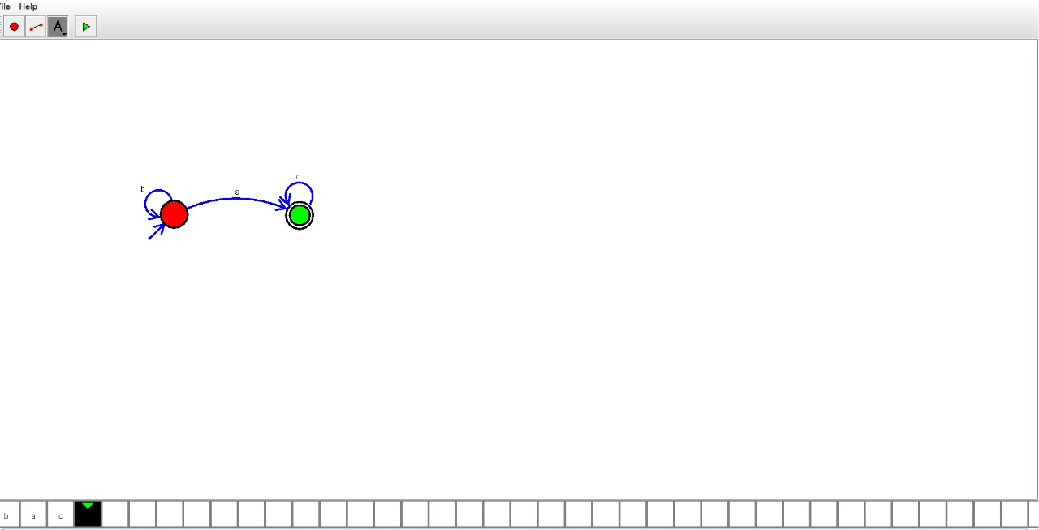

**RESULT:**  Hence the string is accepted.